Professional Skills “Highlights” 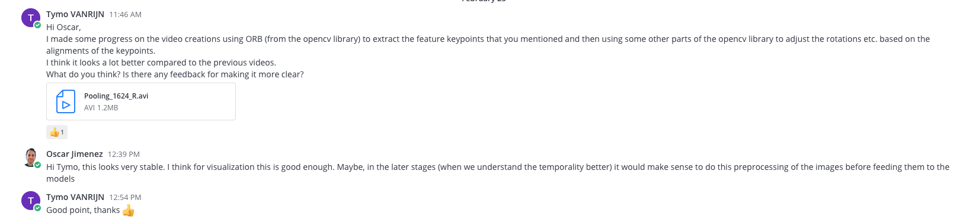
Figure 1 Showing me asking for feedback on something I made and keeping the team up-to-date with my work
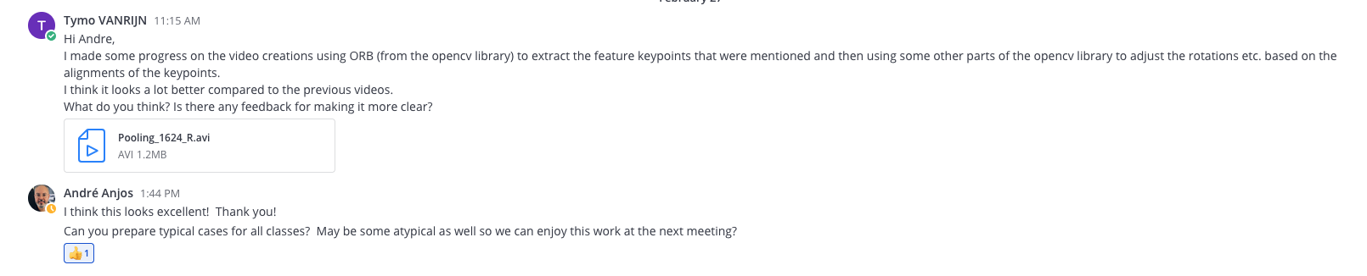
Figure 2 Showing me involving more people to gain more feedback/replies on something I made and keeping them up-to-date with my work
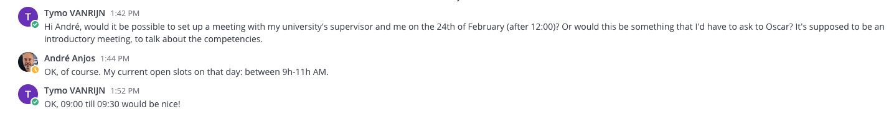
Figure 3 Showing me setting up a meeting with the school supervisor and the company supervisor
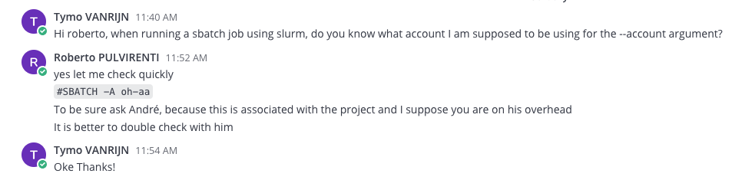
Figure 4 Showing me asking for help whenever I am stuck and cannot fix it on my own
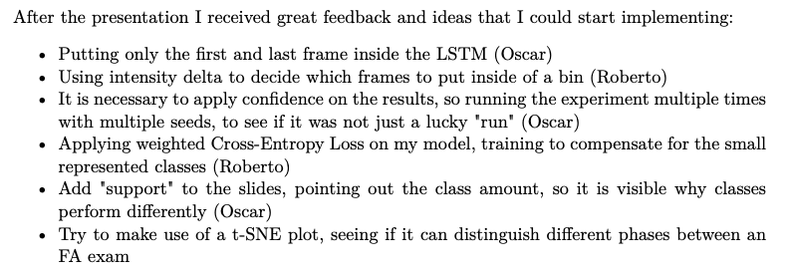
Figure 5 Showcasing the feedback I received after a weekly meeting with Roberto and Oscar (Logbook p.24))
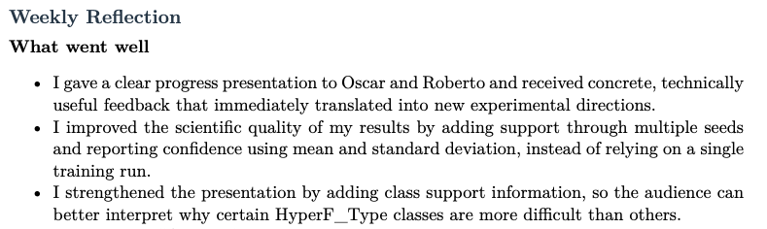
Figure 6 Showing I took the feedback from Oscar and Roberto serious by implementing the mentioned points (Logbook P.28)
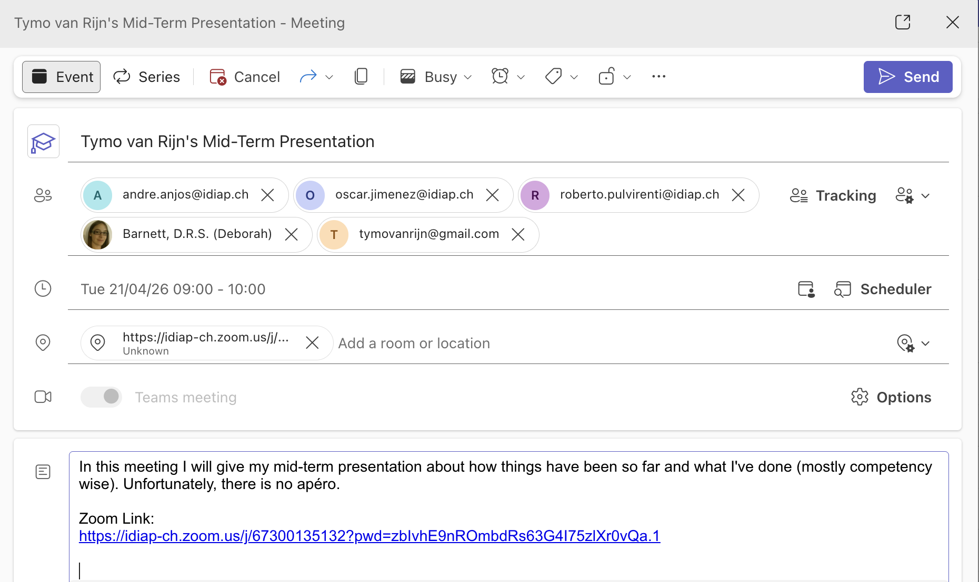
Figure 7 Showcasing me creating a meeting that include different parties (Hogeschool and Idiap)
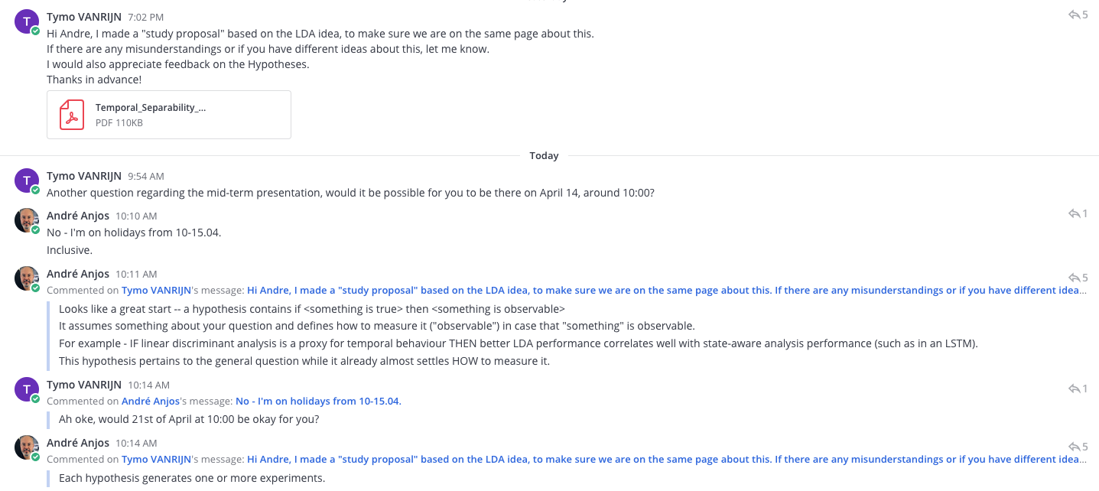
Figure 8 Showcasing me updating André with something I made and asking him for feedback on it (+ Setting up a meeting)
Figure 9 Showcasing me turning the received feedback into action points
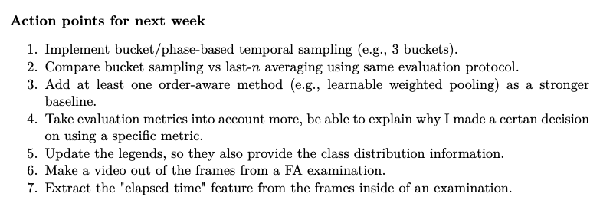
Figure 10 Showcasing me making actual action points based on the feedback I had received from my supervisors during the meetings
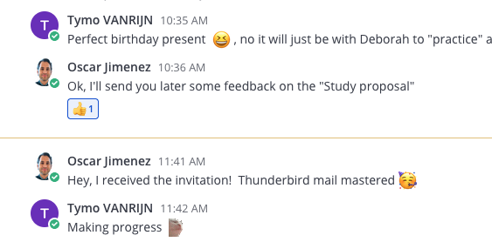
Figure 11 Showcasing me having a conversation with one of my supervisors in a rather "funny way". I used a custom dancing cat emoji to brighten up his day, and thereby hoping our work and teamspirit would increase.

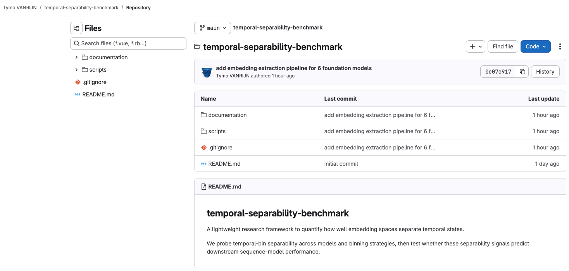
Figure 12 Showcasing an example of a GitLab repository managed by me for a specific study
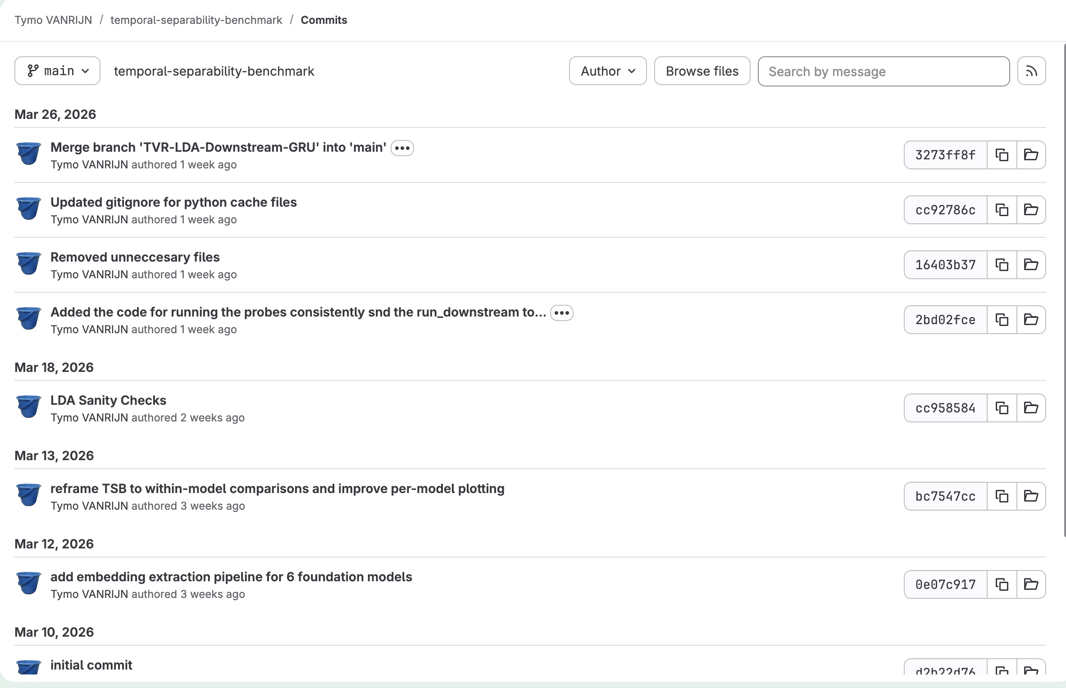
Figure 13 Showcasing branch commit history
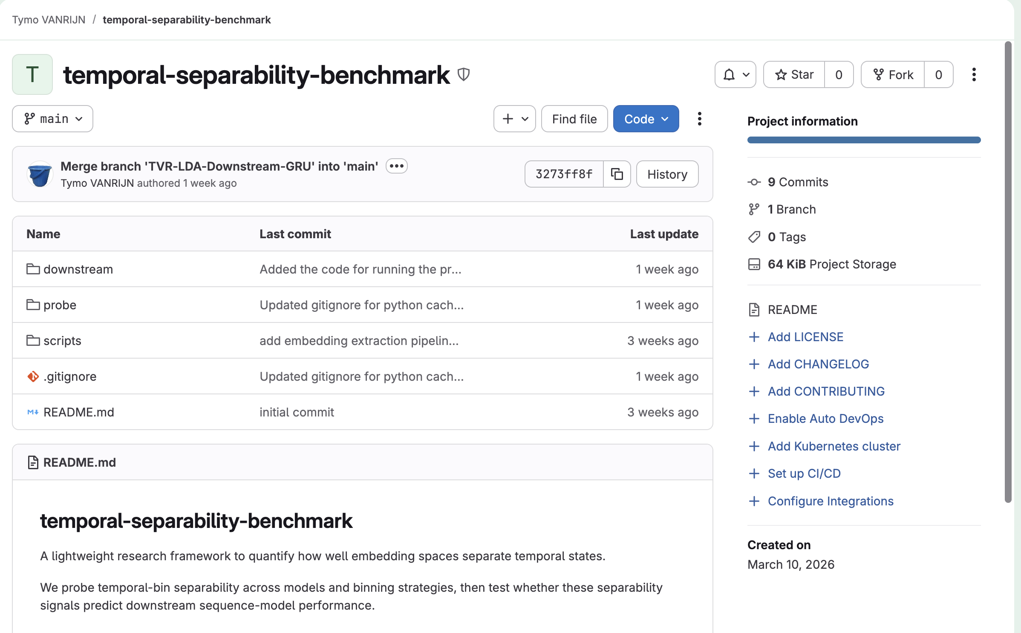
Figure 14 Showcasing the split between different functionalities for the repository in different directories (structured, reproducible)
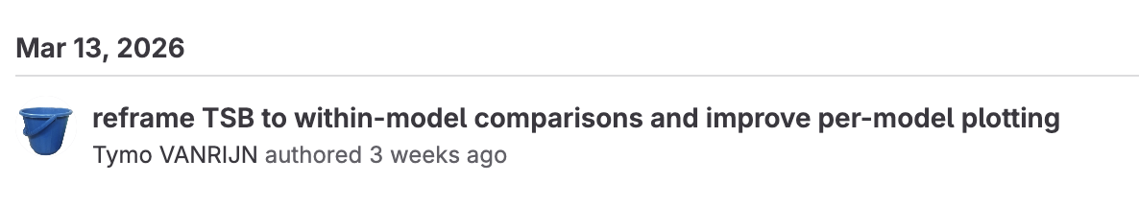
Figure 15 Showcasing me changing things around when the model vs. model comparison was not fair, so I had to change it to within-model comparison.

